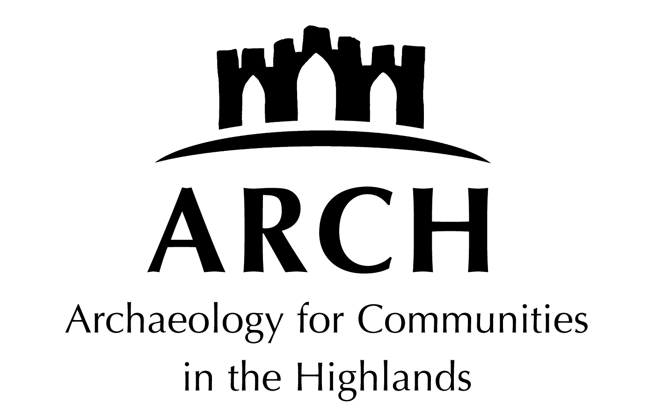
Highland Archaeology

A select list; most books are available from Highland Council library system. The North of Scotland Archaeological Society (NOSAS) collection is in Dingwall library, available as reference to the public or loan to members. See www.nosas.co.uk

Archaeological theory and techniques

Beginners: Try starting with a children's guide – e.g. The Dorling Kindersley Eyewitness Guide Archaeology. There are then a number of 'How-to books' if you wish to explore this further.

Archaeology is Rubbish. A beginner's guide – Tony Robinson and Mick Aston
A good all round introduction, with good illustrations. More detailed than children's guides.

The Handbook of British Archaeology – Lesley and Roy Adkins
Dry, thorough encyclopedia structured both by period and by techniques. Useful if you are trying to cope with archaeological reports, academic articles or jargon.

Scottish Archaeology

Historic Scotland’s The Making of Scotland Series (published by Birlinn)
Good introductions with plenty of reconstructions, photographs etc, though becoming out of date. Recommended for beginners and more advanced readers. Some now with 2nd editions.
Wild Harvesters: The first People in Scotland- Bill Finlayson (2nd rev ed, 2005)
Farmers, Temples and Tombs: Scotland in the Neolithic and Early Bronze Age – Gordon Barclay (2nd rev. ed 2005)
Settlement and Sacrifice. The Later Prehistoric People of Scotland – Richard Hingley (2nd rev ed 2005)
Surviving in Symbols: A Visit to the Pictish Nation – Martin Carver (2nd rev ed 2005)
A Gathering of Eagles: Scenes from Roman Scotland – Gordon Maxwell (2nd rev. ed, 2005)
Angels, Fools and Tyrants: Britons and Anglo-Saxons in Southern Scotland – Chris Lowe (1999)
The Sea Road: A Viking Voyage Through Scotland – Olwyn Owen (1999)
Alba: The Gaelic Kingdom of Scotland, AD 800-1124 – Stephen Driscoll (2002)
Saints and Sea Kings – Ewan Campbell (1999)
The Age of the Clans: From Somerled to the Clearances – Robert Dodgshon (2002)
Puir Labourers and Busy Husbandmen: The Countryside of Lowland Scotland in the Middle Ages – Piers Dixon (2002)
Burgess, Merchant and Priest: Burgh Life in the Scottish Medieval Town – Derek Hall (2002)

Historic Scotland also publishes a more detailed series. These are also useful & well illustrated, though even more out of date in places (look for 2nd editions if possible):
Scotland's First Settlers – C.R. Wickham-Jones (1994); Neolithic and Bronze Age Scotland – P.J. Ashmore (1996); Celtic Scotland – Ian Armit (1997); Roman Scotland – David Breeze (new ed 2007);
Picts, Scots and Gaels – Sally Foster (new edition, 2004); Viking Scotland – Anna Ritchie (2001); Medieval Scotland – Peter Yeoman (1995); Pilgrimage in medieval Scotland – Peter Yeoman (1999)

Scotland. Archaeology and Early History – Graham and Anna Ritchie (2nd ed. 1991)
Good overview of prehistoric through Pictish period in Scotland as a whole, though dated.

Highland Archaeology

FINALLY: an overview of Highland heritage from earliest times to 21st c is available on https://scarf.scot/regional/higharf/ with summaries, datasheets, case studies, comprehensive bibliography and much more. In 2022 pdf versions will also be available. The first place to look!
The Highlands – Joanna Close-Brooks (HMSO, 2nd ed. 1995)
Gazetteer and touring guide, with chapters divided by themes and types of monuments. Not comprehensive, but useful, especially for historic periods.

Ross and Cromarty: A historical guide – David Alston (1999)
General history and archaeological gazetteer. Best for later periods.

Moray & Badenoch. A Historical Guide – Richard Oram (1996)
General history and archaeological gazetteer

Sutherland: An archaeological guide – Robert Gourlay (1996)
Brief chronological summary and gazetteer, written by former Highland Council archaeologist.

Caithness Archaeology: aspects of prehistory – A. Heald and J. Barber (2015). A personal overview.

The Hub of the Highlands. The Book of Inverness and District – Inverness Field Club (1975)
Dated, but still some useful chapters on archaeological remains in the Inverness area.

Highland Community Timelines – Susan Kruse
Overview with examples of Highland archaeology, with information derived from ARCH classes.

Other useful works and websites:

Multi-period
SCARF www.scottishheritagehub.com/ published 2012
Up- to-date website with state of knowledge of Scottish archaeology and outlining future research priorities. Can be dense and highly academic, but indispensible for finding out current knowledge.

- Proceedings of the Society of Antiquaries of Scotland (PSAS) http://journals.socantscot.org/index.php/psas
The yearly proceedings have been published since the 19th century, and provide the main place where archaeological themes and excavation reports appear.

- Discovery and Excavation in Scotland
https://archaeologyscotland.org.uk/join-us/discovery-and-excavation-scotland/
Brief summaries of recent excavations – sometimes the only way to find out what has occurred, until the site is published. Up to 2016 on the Archaeology Scotland website.

Scottish Archaeological Internet Reports (SAIR) www.sair.org.uk
A number of useful and important excavation reports are now published directly to the internet.

Archaeology Reports Online (ARO) https://www.archaeologyreportsonline.com/
Also published archaeological reports and some research papers online.

SCRAN website www.scran.ac.uk
Scottish culture on line, with illustrations from many museums, video clips of techniques and re-enactments, and much more. Non subscribers only see small 'thumbnails' and captions, but Highland Council has a subscription, so use at the libraries or type in your library card details!

The Archaeology of Skye and the Western Isles – Ian Armit (1996)
Well written and informative. Especially good for those people interested in the Iron Age, providing the next step after the Historic Scotland books.

Atlas of Scottish History to 1707 – ed. Peter G. B McNeill and Hector L MacQueen (1996)
For those who like distribution maps for their data!

Treasure Trove Scotland www.treasuretrovescotland.co.uk
With list and some illustrations of Treasure Trove material from 2005.

The Landscape of Scotland. A Hidden History - C.R. Wickham-Jones (2001)
Pictures and descriptions of surviving archaeological monuments in the landscape. Recommended for those people who like to try and identify what they see as they travel or walk.

Identifying the historic environment in Scotland’s forests and woodlands – Matthew Ritchie and Jonathan Wordsworth (2010). Useful practice guide on identifying sites, with good illustrations. Free download from Forestry and Land Scotland website https://www.forestresearch.gov.uk/research/identifying-the-historic-environment-in-scotlands-forests-and-woodlands/

Place names of Ross and Cromarty - W.J. Watson (1904, reprinted at various times thereafter).
One of the classic placename studies, full of interesting detail. A must if you live in or are familiar with Ross & Cromarty!

Prehistoric
Scotland's First Settlers Project
Important project investigating Mesolithic settlements in western Highlands and Skye. The website has disappeared, the report is published online in SAIR31 www.sair.org.uk. Full archive now available on-line too.

Mesolithic Lives in Scotland – Graeme Warren (2005)
Thought-provoking, especially on issues concerning what interpretations can be drawn from fragmentary evidence.

The Chambered Cairns of the Central Highlands – A.S. Henshall and J. N. G. Ritchie (2001)
Discussion and gazetteer of a very common prehistoric burial type in the Highlands. For elsewhere in the Highlands, see Audrey Henshall’s earlier publication The Chambered Tombs of Scotland and The Chambered Cairns of Sutherland.

Scotland after the Ice Age. Environment, Archaeology and History 8000 BC – AD 1000
ed. by Kevin J. Edwards and Ian B.M. Ralston (2003).
A number of articles on climate, environment, and history, with summaries of issues. Quite dense and academic in places, and new research is now available, but if you're interested in the period, this is a good place to begin.

Symbols of Power at the time of Stonehenge. - D.V. Clarke, T.G. Cowie, A. Foxton (1985).
Beautifully illustrated catalogue from an exhibition of Neolithic and Bronze Age elite objects, with interesting discussion. Reference copies in Inverness Library and Dingwall Library.

Bronze Age Britain - Michael Parker Pearson (2nd ed. 2005)
Despite the title, it deals with Mesolithic, Neolithic and Bronze Age Britain. Covers some of the Scottish evidence, and places it in the context of what is happening elsewhere in Britain.

The Beaker People. Isotopes, mobility and diet in prehistoric Britain, ed by Mike Parker Pearson et al (2019). A definitive work, full of details.

Brochs of Scotland – J. N. G. Ritchie
Small Shire publication, but useful summary of this widespread Highland Iron Age monument

Towers in the North. The Brochs of Scotland – Ian Armit (2003)
A detailed and readable study of brochs.

The Crannogs of Scotland – Nicholas Dixon (2004)
Although disorganised in parts, this is the only modern survey of crannogs in book form.

The Iron Age in Northern Britain. Celts and Romans, Natives and Invaders – D.W. Harding (2004)
Synthesis of the Iron Age in Scotland. Heavy going and academic in parts, and the division of the Iron Age into different periods means there is no one discussion of the Highlands. However, thought-provoking.

Romans
www.curlesnewstead.org.uk Full publication of Curle's classic report on the Roman Fort of Newstead where there was excellent preservation. Can be viewed online or downloaded as pdfs

Beyond the edge of the empire – Caledonians, Picts and Romans – Fraser Hunter (2007).
Publication by Groam House Museum of an important lecture.

Pictish
Portmahomack on Tarbat Ness by Martin Carver, Justine Garner-Lahire & Cecily Spall (2016). Definitive publication of this important site. Downloadable from Soc.of Antiquaries of Scotland.

The Art of the Picts. Sculpture and Metalwork in Early Medieval Scotland – George and Isabel Henderson (2004). In depth, dense and definitive, with the art historical evidence foremost.

The Pictish Stones of Scotland – Iain Fraser (2008).
Comprehensive date listing and discussion.

Vikings
Vikings in Scotland. An archaeological survey – James Graham-Campbell and Colleen E. Batey (1998)
For those interested in the Vikings, the next step after the Historic Scotland books.

Scar. A Viking Boat Burial on Sanday, Orkney – Olwyn Owen and Magnar Dalland (1999)
A rare example of an excavation report which is readable and informative for academic, expert and layperson. Recommended, especially for Viking enthusiasts.

Medieval
The Middle Ages in the Highlands, published by Inverness Field Club (1981)
A few of the articles deal with archaeology and architectural remains.

Finlaggan website https://www.finlaggan.org/
Information about excavations at this important site, with illustrations of some finds.

Medieval Cromarty Uncovered – Caroline Vawdrey. Small pamphlet as we await publication of this important site.

Post Medieval
The Northern Isles: Orkney and Shetland - Alexander Fenton (1978, republished 1997)
Scottish Country Life - Alexander Fenton (1976, revised ed 1999)

Country Life in Scotland: our rural past – Alexander Fenton(2008)
Well illustrated, with many old photographs, of country life. Especially useful when looking at aspects of daily life.

Buildings of the Land: Scotland’s Farms 1750-2000 - Miles Glendinning & Susanna Wade Martins, (2009). Well illustrated survey of post improvement farms throughout Scotland.

Industrial Archaeology of Scotland. 2. Highlands and Islands – John R. Hume (1977)
Reference copies available in Dingwall and Inverness libraries.

